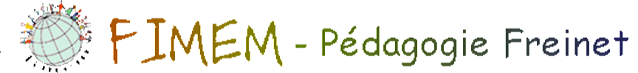
I thought it’s appropriate to take up this letter from the Presidency, published after the Lokossa meeting in 2017, because it reflects exactly what you will find in the moral report, the report on the activities of the 2016-2018 Board and the orientations: perspective 2018-2020. Sorry about the duplicate for those who had already read it!
Letter from the Presidency
Reminding the principle of connected vessels, that is so dear to Freinet movement:
"A strong collective strengthens each individual and group and strong individuals and groups shape and strengthen the collective.
Why FIMEM? For whom?
My four-year experience on the board of FIMEM brings me to question the usefulness of our Federation in its current form and to explore with you promising ways to strengthen and modernize it in the very near future.
This extraordinary tool promoting, consolidating and mobilizing can really play a more important role together with all those who are interested in FP and therefore concerned about all the environmental phenomena that have an undeniable influence on the school.
I am thinking of the involvement of the member movements, of course, but also of all the members who feel concerned and wish to share their ideas to ensure the vitality, influence and sustainability of FIMEM?
What must be changed, what must be modified so that FIMEM becomes an unavoidable for all those who choose to join?
A few leads:
I- An elected Board that is productive, committed and available
that initiates, suggests, consults, validates, groups, coordinates and makes available good practices, both from an organizational and pedagogical point of view.
To keep going this enormous amount of work, we need explicit, targeted and variable skills according to the problems and priority orientations of the moment. This is why we have developed a competency profile (criteria) and proposed a pre-action support for anyone wishing to commit to the Board (possibility of participating in virtual meetings and preparatory days for the GA).

II-Local correspondents in direct and constant contact with FIMEM
Ideally, each Movement would entrust 1 or 2 of its members with the explicit role of communication agent". These motivated, reliable and credible members already involved within their Movement, would have as their main task to improve COMMUNICATIONS internally, with other Movements and with FIMEM. It is fundamentally to have circulating information in the various local, regional, national and international authorities. These key interlocutors (delegates perhaps) would commit themselves for a 2-year term.
III-Extended Board of Directors
Sweden has chosen "communication in all its forms" as the theme for Ridef 2018. And this is what FIMEM needs the most at the moment... during the Ridef of course but especially to maintain the time BETWEEN the Ridef.
If the interest is there, a choice of several "thematic projects" could be proposed to the participants (old and new) who will want to share their ideas of transformation and to make us gift of their expertise, their interests and their talents.
As examples:
Area 1-Reciprocal expectations: needs of the Movements towards FIMEM? Contributions expected by FIMEM?
Area 2- Ridefs organizers: winning practices to share
Area 3- Organizational heritage: history of decisions, management tools, guide official cards to ensure the continuity and effectiveness to successive members of the Board?
AREA 4 -Site FIMEM: Used or not? Useful or not? Suggested improvements to improve usability where appropriate
Area 5- Other subjects: initiated by the Movements or suggested by FIMEM. There are already several ones on our work table (see the section "Issues under consideration" in Infor 70)
This is what will make this Federation, which brings us all together, more and more important for us. Informing, consulting, sharing, mobilizing and getting involved could be our "collective leitmotiv" for the coming years. Who will join us?
Ridef 2018...it's a date! I'll be there. And you?
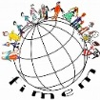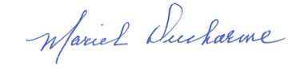
President of FIMEM

