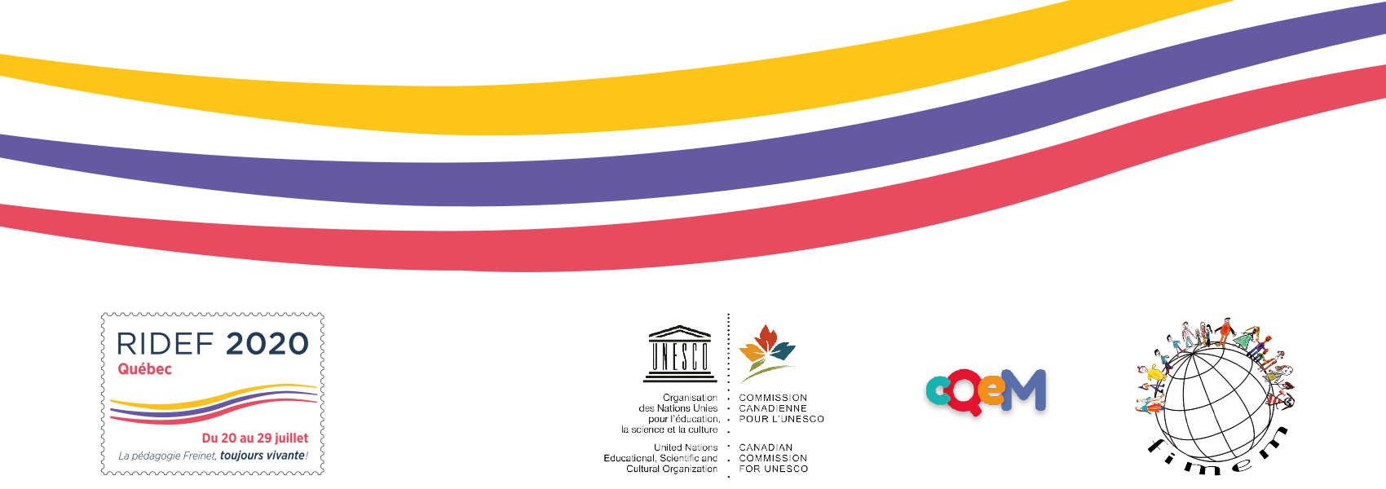

In memoriam
We want to take a moment to honour the Freinet educators who have passed away over the past two years. We want to remember all that they have taught us.
So please complete this form and return it to us by June 30, 2020.
The compilation of the cards received will be communicated to you via the Facebook page "Ridef Québec 2020" and by email.
Thank you in advance!

Return to
mariel.ducharme@gmail.com
« In memoriam » form
1-Name of the deceased person
2-Movement/Country
3-Place and date of death
4-Principal contributions to Freinet's pedagogy or
her Movement

5-Additional informations and your main collaborations with this person

6-Attach a photo
7-Your name
8-Your email
9-Repeat your email:
10-Comments

