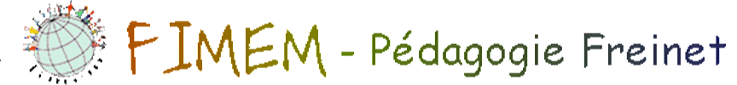

The meetings report of December, 2016, January and February 2017.
Administration meeting advice
The coming meeting will take place in Benin, in the town of Lokossa on June, 28th to July, 4th 2017.
Benaiges
The administration advice has taken a decision to hold the payment of 2017-2018 in reserve and waiting for evaluation of the situation. The payment of 2017 and 2018 (500 euros/year) will be reserved when the stock exchange or scholarship reach the amount of 3000 euros, which was proposed for the year 2015 and 2016. (2000 euros for the FIMEM and 1000 euros for Spanish movement.)
The FIMEM wish to meet the Spanish movement in Sweden to make the account on Benaiges’ holl project. The FIMEM asks Pilar, who was allowed to be near the Benaiges’ Association, to be replaced all the time she is not able to come to the congress association meeting.
CAMEM
To enforce their influence in Africa, the FIMEM proses to the CAMEM an affiliation to the federation as a continental member with right of vote and fees payment.
Fees of the movement.
It is précised in the request of payment to the movements that the ad of 10% is compulsory.
Project.
The FIMEM has propped a sum of 200 euros for each of the three projects: Burkina Faso, Cameroon and Congo. It is waiting for these movements an information on the work which will be realize with this money: date, place, number of all participants, type of meeting and the description of how 200 euros will be used before sending the money.
Haïti.
We have notify to Jean-Marc that we are waiting for the best evolution of the situation in this country and we will join him about the payment after the meeting of July.
RIDEF
ABEM has finished with RIDEF with an important lack which will affect the law level of all FIMEM budget.
Flyer:
It is now available in three languages on the site.
Documents in English.
Katrien has sent a group of reflection for producing the documents in English.
You can find the link FB on the site.

